**Applied Data Science 1 – Assignment 1:Visualisation**

STUDENT NAME: ROHITH KONDA

STUDENT ID: 22071628

GitHub: [https://github.com/rkrohith23/AppliedDS1]

References:

Kaggle, 2023. Petrol/Gas Prices Worldwide. [Online]

Dataset link: https://www.kaggle.com/datasets/zusmani/petrolgas-prices-worldwide?select=Petrol+Dataset+June+20+2022.csv

__________________________________________________________________

**Analysis of Global Petrol Consumption and Pricing**

**Introduction:**

The patterns of global petrol consumption and pricing provide insights into economic behaviors and energy utilization. In this report, we use data visualization to analyze these patterns, focusing on the top countries by share of world consumption. The three chosen graphical representations help us to understand the disparities in petrol pricing and the concentration of consumption among countries

**Graph 1: Comparative Petrol Pricing - Line Chart**

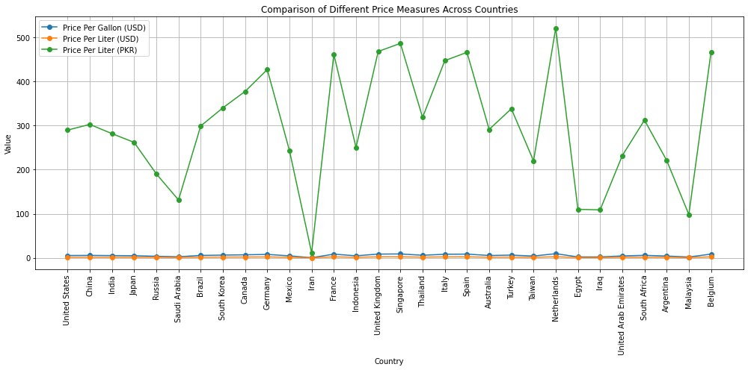

The line chart reveals the differences in petrol pricing across various countries. It provides a perspective on how the price per gallon and price per liter in USD and PKR (corresponding prices in US Dollars and Pakistan Rupee) fluctuates over the top 30 countries. We observe a wide range in prices, indicating the influence of taxation and economic status on petrol costs.

**Graph 2: Delineating Consumption Shares - Pie Chart**

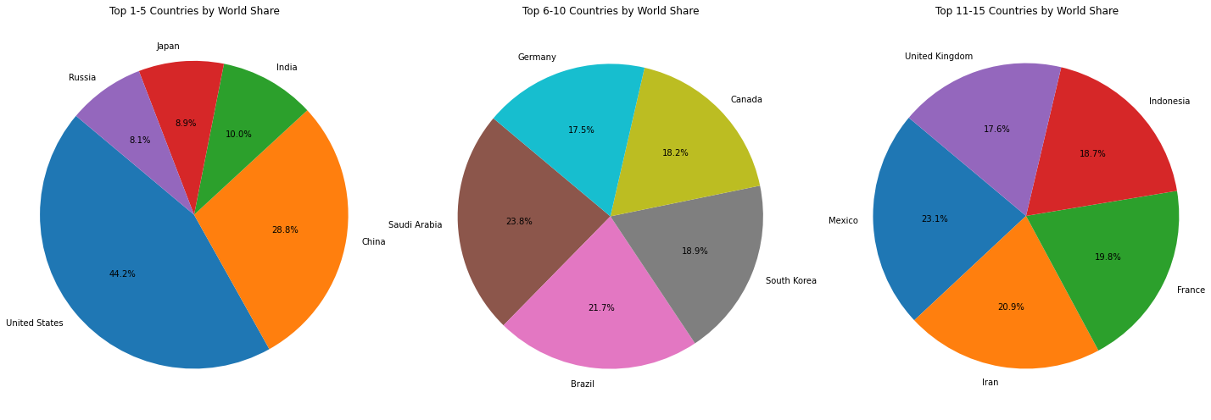

Our pie chart series segments the world's petrol consumption into top 15 countries, offering a clear visual breakdown of each country's share. It is evident that a small number of countries are responsible for a large portion of the consumption, suggesting a lopsided demand in global energy markets.

**Graph 3: Visualizing the Top Consumers - Bar Graph**

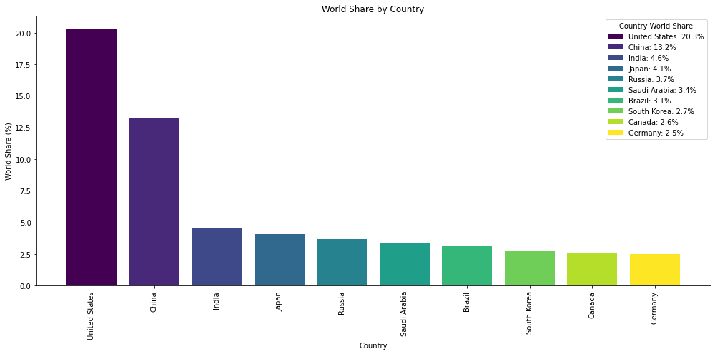

The bar graph accentuates the world share of petrol consumption for the top 10 countries, with each country differentiated by color. The sharp differences in the height of the bars indicate the dominance of certain countries in petrol usage, with a significant fall-off as we move down the list.

**Conclusion:**

In summary, the analysis of the line, pie, and bar charts gives us a nuanced picture of global petrol consumption and pricing. While prices show considerable variability, the consumption is heavily skewed towards a few countries. This disparity highlights potential vulnerabilities in energy distribution and opportunities for policy reform in the energy sector. The data portrayed in these charts calls for continued scrutiny and strategic planning to ensure sustainable energy consumption patterns worldwide.